 | Beginning.  characters and setting | Middle  Problem. building tension | End  Solution
Picture | 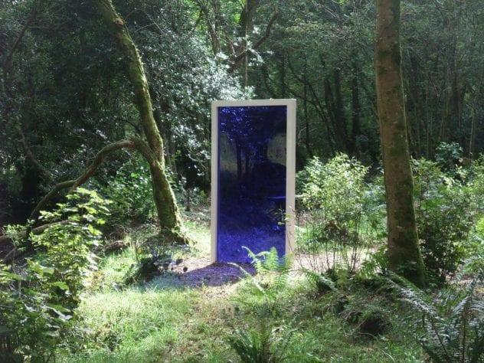
Details | When?  Where?  Who? | What went wrong?  What caused the problem? | How did they fix the problem?
Adjectives | The main character:  The setting:

